

SEDL 8810
Manual Price Report
should not restrict CANC entry
when price is last sale or opening trade

Test Plan Document

Prepared by: Mike Hasbrouck

Table OF contents

Test Setup Instructions: 3
1. Trading Properties 3
2. Routing Properties 3
Test1. Manual Price Report CANC entry, should not be prohibited when price is either last sale or opening trade 4

Test Setup Instructions:

Properties Settings

DEFAULT Setting to be used by all Test Case (unless explicitly specified)
- Use a class with a Product Description of ‘EQUITY D PENNIES ALL’

1. Trading Properties
- ‘Auction Enabled for New Hal (-8)’ = True
- ‘Allowed HAL Origin Codes’ = False for C, M, F, A, P
- ‘Auto Link Origin Codes’ = True for C, M, F, A, P
- ‘Allow Market Order’ = True

2. Routing Properties
- ‘Help Desk Default Destination’ = <OMT User> (ex. HOMT1)
- ‘Firm Volume Limit Simple Order’ = 4999
- ‘Volume Deviation Check Simple Orders’ = 4999, Level = 1, Deviation = All
- ‘Volume Deviation Check Complex Orders’ = 4999, Level = 1, Deviation = All

Test1. Manual Price Report CANC entry, should not be prohibited when price is either last sale or opening trade

# | Action | Input Values | Expected Results
1 | Set Product State to ‘Open’ from SA GUI | ➔ | - Product is in ‘Open’ State
2 | MM1 Enters Quote on option Product | Bid: $1.00 X 1000  Ask: $1.20 X 1000
  Exchange: | Bid: | Ask:
  CBOE | 1.00x1000 | 1.20x1000
2a | MM1 Enters Quote on equity Product | Bid: $10.00 X 1000  Ask: $10.20 X 1000
  Exchange: | Bid: | Ask:
  CBSX | 10.00x1000 | 10.20x1000
3 | Create Complex Buy_Write Product | Defined as Sell 100 equity / Sell 9 option
4 | Enter order to route to PAR | ORD1: Buy 20@MKT, Origin=’C’, Defined side | - ORD1 appears on PAR terminal
5 | Endorse Order fully | Can trade with multiple parties
6 | Enter trades on option leg of buy_write | Create multiple trades at the bid and offer prices
4 | Using a trader gui, submit a Manuel Price with a CANC prefix at the price used for the endorsement of the Buy_Write on PAR | 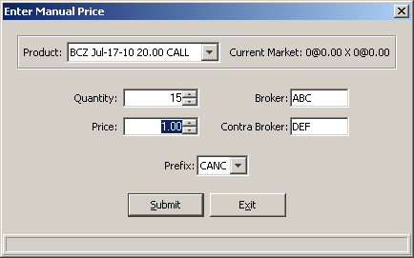 | - Manual Price accepted and Last Sale prefix displays CANC 15@1.00

